**Change the text for The short papers page. Text provided below**

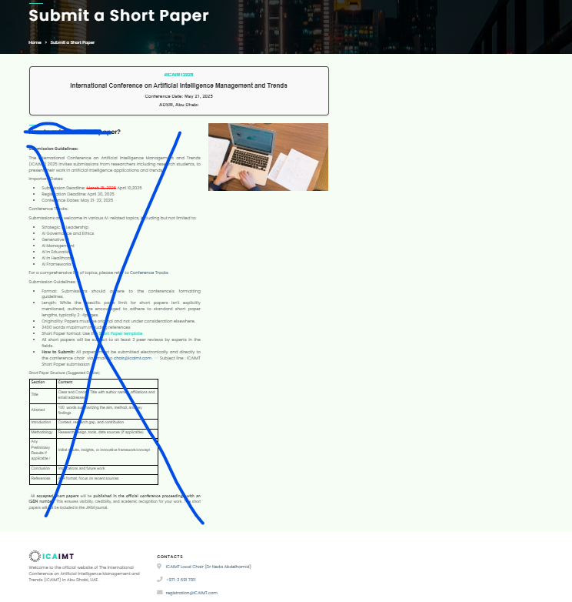

**Call for Short Papers**

The International Conference on Artificial Intelligence Management and Trends (ICAIMT) 2025 invites submissions from researchers including research students, to present their work in artificial intelligence applications and trends.

Deadline April 10th, 2025

All **accepted short papers** will be **published in the official conference proceedings with an ISBN number**. ONLY selected high quality short papers will be invited to submit an extended version for potential publication in the following Q1 and Q2 , Impact Factor international academic journals :

1. [Journal of Modelling in management](https://www.emeraldgrouppublishing.com/journal/jm2) Q2, Emerald  
   Special Issue focus: *AI for Business and Management*  
   Guest Editors: Davide La Torre (SKEMA Business School, Université Côte d’Azur, Sophia Antipolis, France, [davide.latorre@skema.edu](mailto:davide.latorre@skema.edu) , Dr. Neda Abdelhamid , (Abu Business Analytics , Dhabi School of Management), Abu Dhabi UAE [n.abdelhamid@adsm.ac.ae](mailto:n.abdelhamid@adsm.ac.ae) , Dr. Cinzia Colapinto (Department of Management, University of Venice, Italy.)
2. [*Information Processing and Management*](https://www.sciencedirect.com/journal/information-processing-and-management) *Q1, Elsevier*

*Special Issue focus: AI for Business and Management*

Guest Editors: Davide La Torre (SKEMA Business School, Université Côte d’Azur, Sophia Antipolis), France, [davide.latorre@skema.edu](mailto:davide.latorre@skema.edu) , Marc Poulin( Abu Dhabi School of Management) m.poulin@adsm.ac.ae, Dr. Cinzia Colapinto (Department of Management, University of Venice,) Italy, Dr. Meryem Masmoudi , (Applied Science University in Bahrain) [meryem.masmoudi@asu.edu.bh](mailto:meryem.masmoudi@asu.edu.bh).

**Submission Guidelines:**

Topics: For a comprehensive list of topics, please refer to [Conference Tracks](https://www.icaimt.com/conference-tracks.html)

* Format: Submissions should adhere to the conference's formatting guidelines.
* Length: While the specific page limit for short papers isn't explicitly mentioned, authors are encouraged to adhere to standard short paper lengths, typically 2–4 pages.
* Originality: Papers must be original and not under consideration elsewhere.
* 2400 words maximum including references
* Short Paper format: Use the [Short Paper template](https://www.icaimt.com/assets/templates/shortpapertemplate-ICAIMT.docx)
* All short papers will be subject to at least 2 peer reviews by experts in the fields.

Short Paper Structure (Suggested Outline)

| **Section** | **Content** |
| --- | --- |
| Title | Clear and Concise Title with author names ,affiliations and email addresses |
| Abstract | 100  words summarizing the aim, method, and key findings |
| Introduction | Context, research gap, and contribution |
| Methodology | Research design, tools, data sources (if applicable) |
| Any Preliminary Results if applicable / | Initial results, insights, or innovative framework/concept |
| Conclusion | Implications and future work |
| References | APA format, focus on recent sources |

The organizers have established these guidelines to ensure a standardized submission format and facilitate the review of contributions for the ICAIMT conference.

**Submit a short paper using the form below**

Create a submission form that will send the document to my email [n.abdelhamid@adsm.ac.ae](mailto:n.abdelhamid@adsm.ac.ae)

Form content

Names

email address

phone number

Affiliation

Affiliation Country

Upload

Submit Button.

----------------------------------------------------------------

When the user clicks on submit button the below message is sxent to him to the email provided.

Generate a paper ID starting by 10 as the initial number

Dear Author,

Thank you for submitting your article to ICAIMT 2025. We have received your submission and will begin the review process shortly.

If any additional information is required, we will reach out to you.

Best Regards,  
Dr Neda  
Local Conference Chair  
ICAIMT2025  
Organized by Abu Dhabi School of Management, Abu Dhabi UAE

Subject : Submission Confirmation for ICAIMT2025